Chapter 19, Solution 62.

Consider the circuit shown below.
20 k
40 k
10 k
a

I_{b}
b
I₁
I₂
+
V₂
−
+
−
+
V₁
−
50 k
30 k
Since no current enters the input terminals of the op amp,
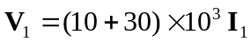 (1)

But 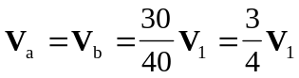

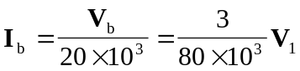
which is the same current that flows through the 50-k resistor.

Thus, 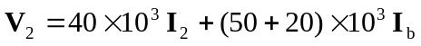
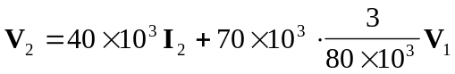
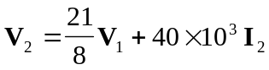
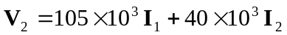 (2)

From (1) and (2),
